Benchmarks for unity ray casting

|  |  |  |  |
| --- | --- | --- | --- |
| Fps(ms) | Num of rays | Num of obj |  |
| 74(13.4) | 72 | 140 | Refrence(1) |
| 74(13.4) | 2592 | 140 | More rays(2) |
| 50(20) | 16200 | 140 | Even more rays(3) |
| 74(13.4) | 72 | 1400 | Even more obj(4) |
| 13(75) | 72 | 14000 | Even more obj(5) |

Gpu and Cpu utilization on scenario (5):

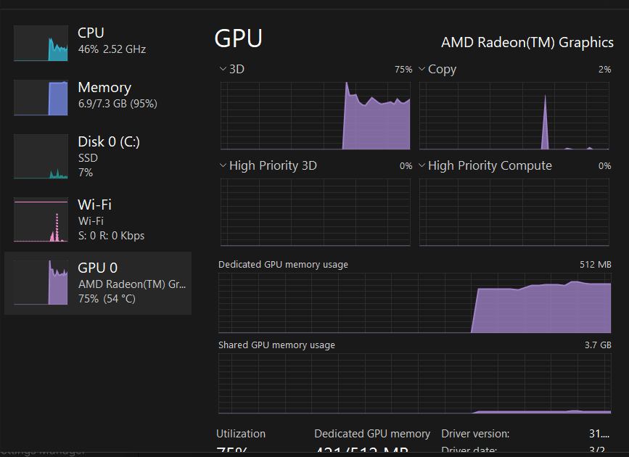

Game view on scenario (1)

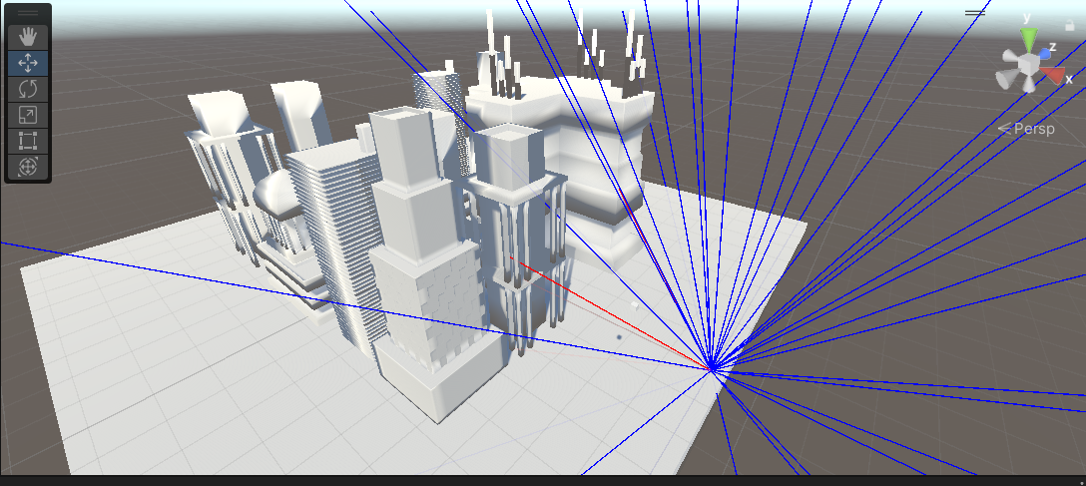

*Blue - No hit , Red – hit